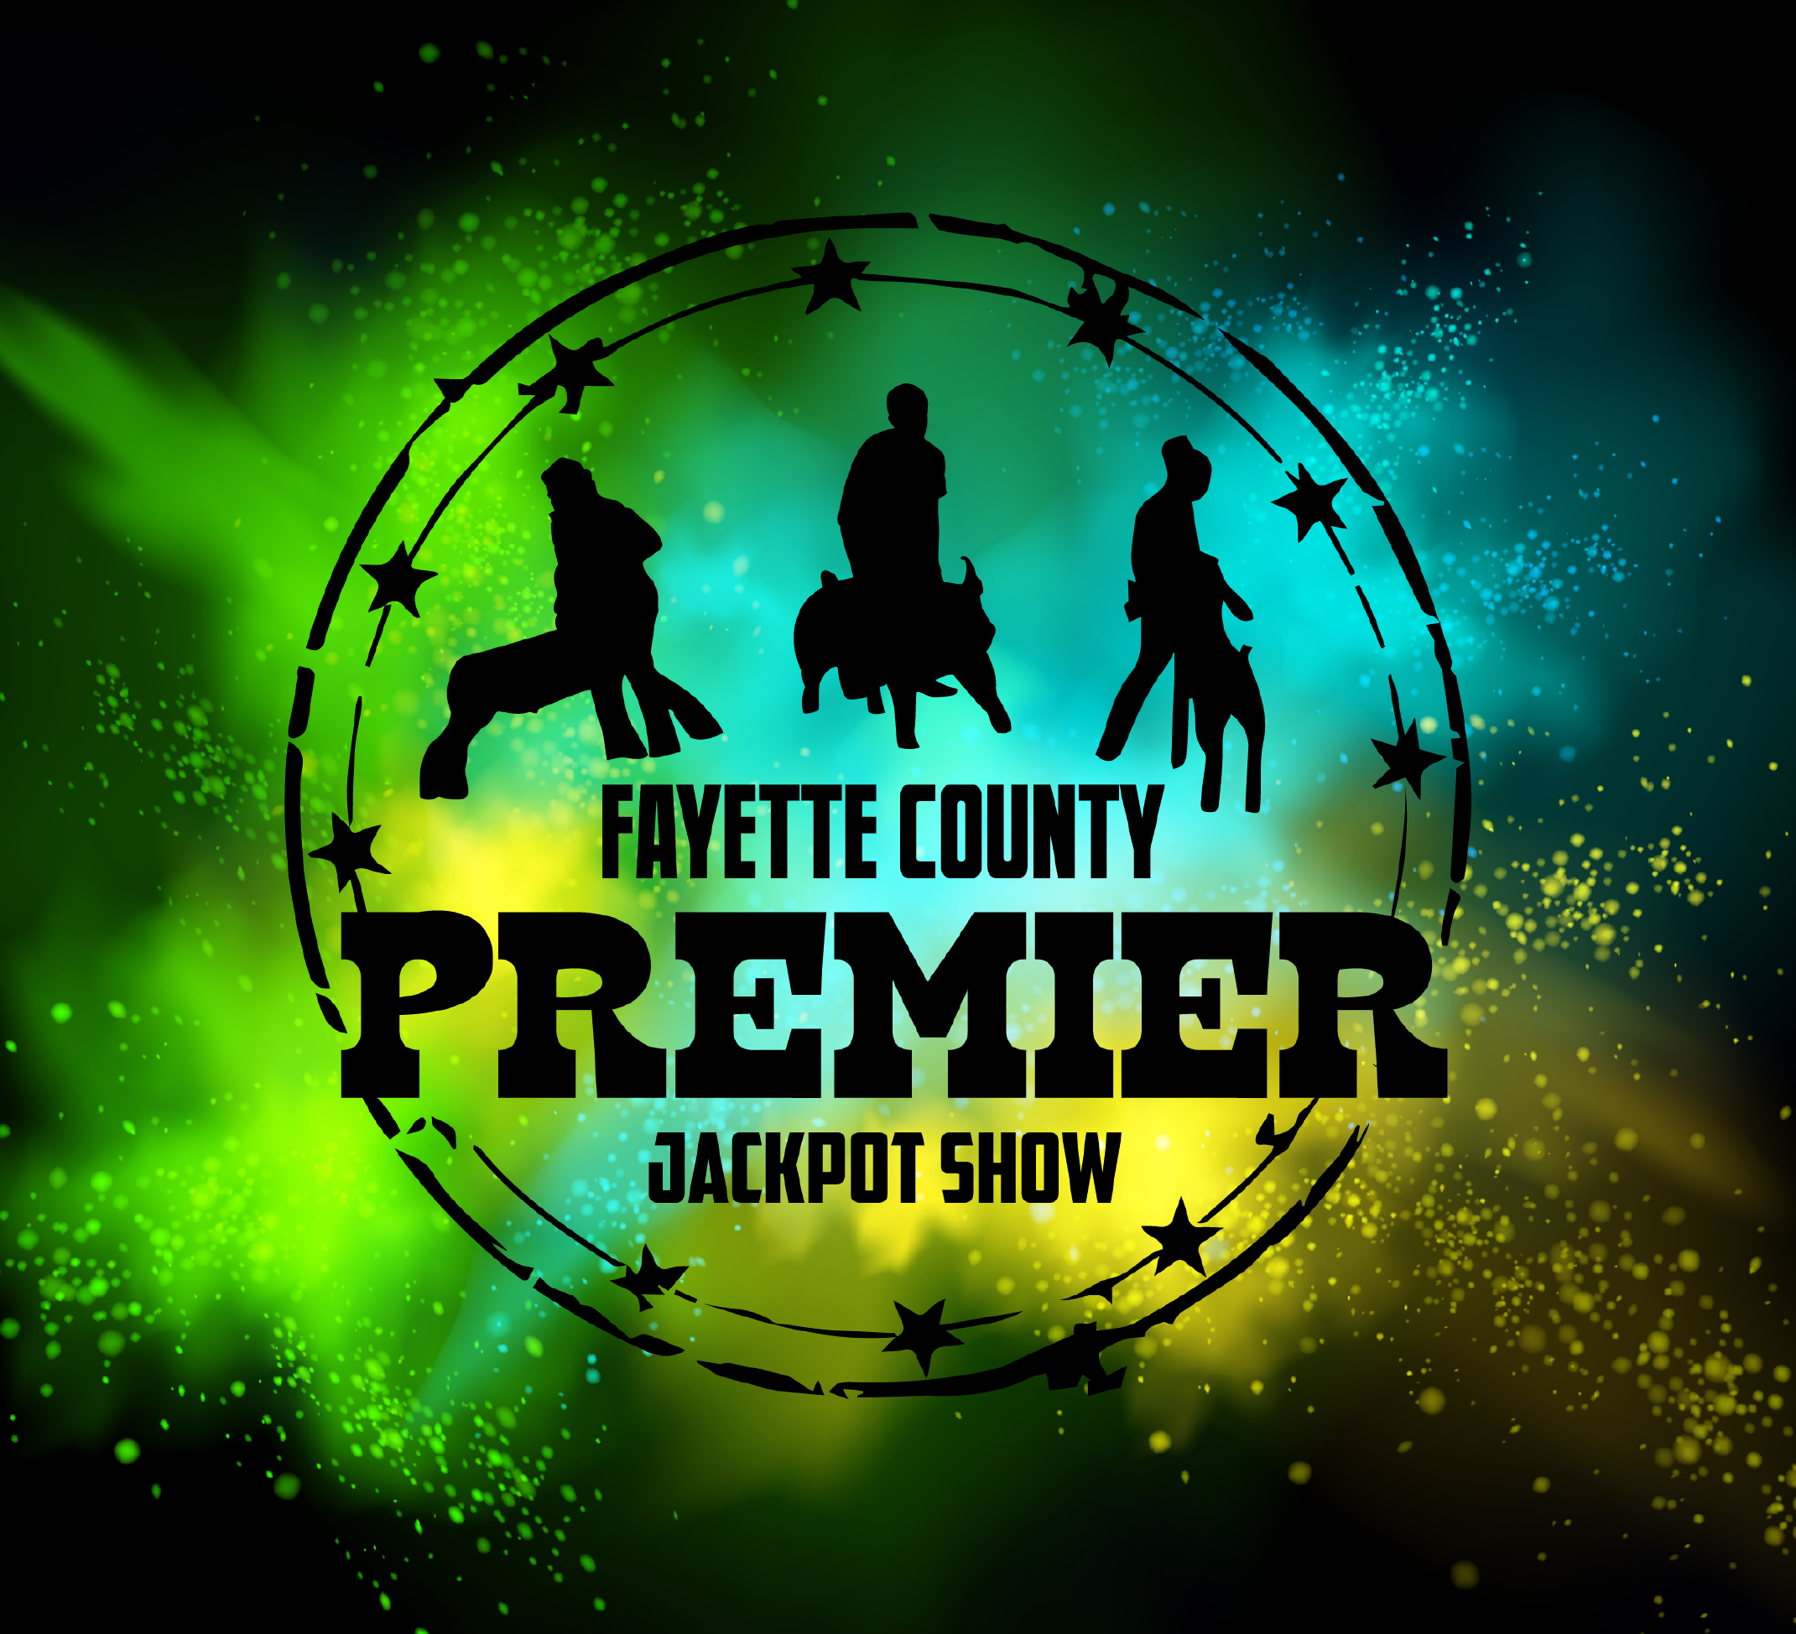
Fayette County Premier
May 20 & 21 2023
749 Flatwoods Rd Vanderbilt, Pa 15486

On behalf of the Fayette County Premier, we are inviting you to help us educate and encourage today’s youth towards becoming tomorrow’s agriculture leaders.
This year we will be holding our Fifteenth Annual Fayette County Premier Jackpot Show for youth in Southwestern PA. The show will be held at the Fayette County Fairgrounds on May 20th & 21st. It will include a lamb, goat and pig show, showmanship classes for all age groups and an educational skill-a-thon event on both days.
Our overall objective is to raise enough donations to be able to pay for the judges, provide each contestant with a keepsake t-shirt, give cash prizes to all class winners, and a grand cash prize for the overall champions for each species.
Please help us make our annual Fayette County Premier Jackpot Show a success! Please send all donations to: Fayette County Premier Jackpot, 749 Flatwoods Rd Vanderbilt, Pa 15486
Sincerely,
Fayette County Premier Jackpot Committee
Lexie Mills, Bill Gardner, Will & Callie Hilty
Please select a sponsorship tier and return to
Fayette County Premier Jackpot, 749 Flatwoods Rd Vanderbilt, Pa 15486
$2,500+ Major Event Sponsor - Name listed on t-shirt and Fayette County Premier’s Facebook page, mentioned throughout the 2-day show. Major Event Show Sponsor will have logo on the show photo back drop banner, sponsor banner in show ring and logo on show advertising information.

$500 Platinum Sponsorship - Name listed on t-shirt and Fayette County Premier’s Facebook page, mentioned throughout the 2-day show, Platinum sponsor will have sponsor banner displayed in the ring both days.

$250 Gold Sponsorship - Name listed on t-shirt and Fayette County Premier’s Facebook page, mentioned throughout the 2-day show. Listing on sponsor banner displayed at show.

$100 Silver Sponsorship - Name listed on t-shirt and Fayette County Premier’s Facebook page, mentioned throughout the 2-day show. Listing on Silver sponsor banner displayed at show.

$50 Bronze Sponsorship – Name listed on t-shirt and Fayette County Premier’s Facebook page, mentioned throughout the 2-day show. Listing on Bronze sponsor banner displayed at show.

Company/Family/Farm Name____________________________________________________
(As you want it to appear on Shirt)
Contact Person ______________________________________________________________________
Address ______________________________________________________________________________
________________________________________________________________________________
Email Address __________________________ Phone number __________________________
Amount Donated _________________
Anyone sponsoring at the Major Event or Platinum or Gold levels needs to email a copy of their logo to be included on all advertising information. Please send to wsg3@hotmail.com.
Please fill out and return all donations by April 25th to be on this year’s t-shirt!

